**Prerequisites**

* Install GIT
* Install Heroku CLI

**Step by step instructions**

1. Go to your project working directory, then right click and select **Git bash** Here

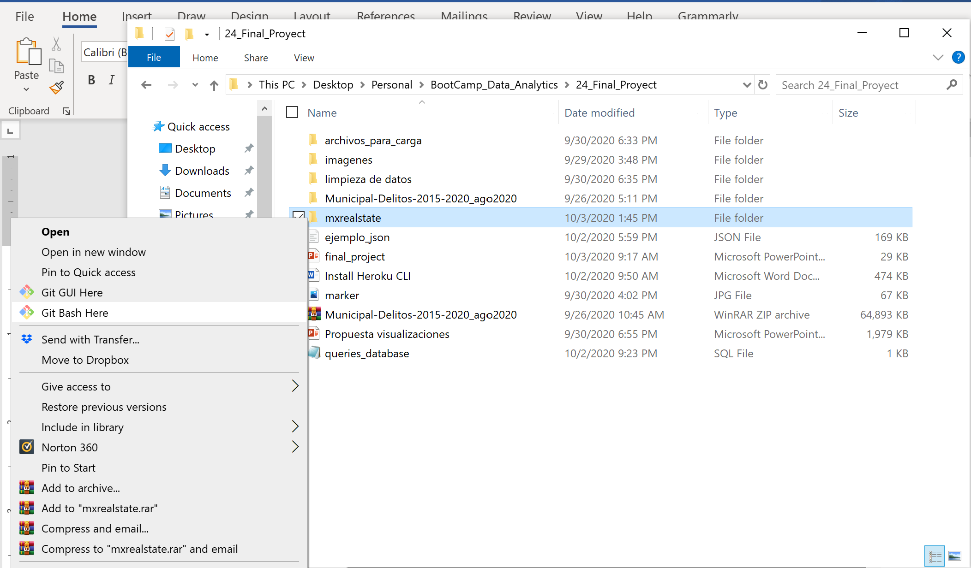

1. Git bash will be open in you working directory.

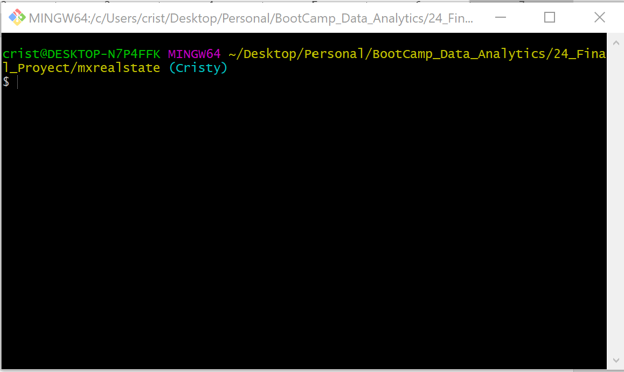

1. Make sure to activate your environment:

source activate **EnvironmentName**

1. Install **gunicorn** with following instruction:

pip install gunicorn

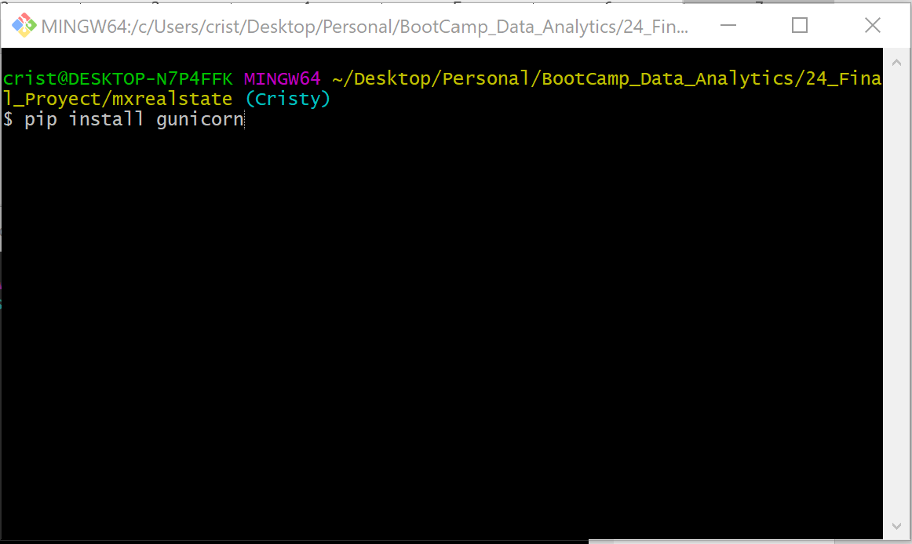

1. Create a file with python runtime version by typing: cat **runtime.txt**
2. Open the file and provide the python version shown in the git bash

Note: In order to verify if the file was created got to your project directory and look for runtime.txt at the root of your project.

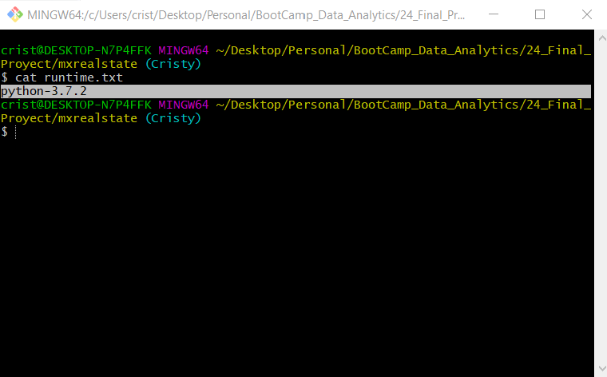

1. Create a Procfile by typing: touch **Procfile**

Inside the created file type the following: web: gunicorn app:app

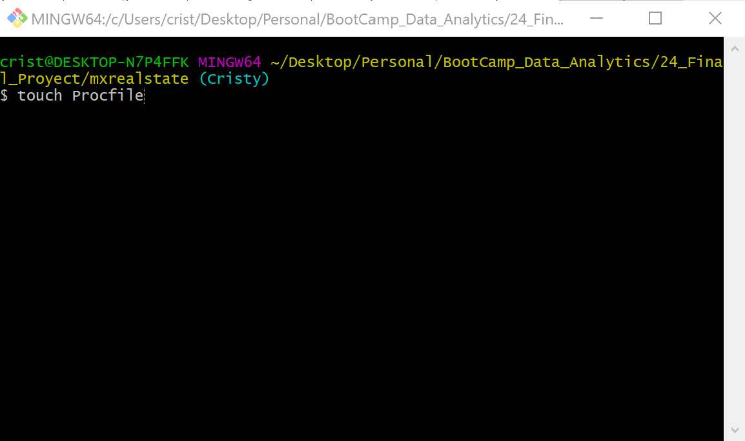

1. Now create the requirements.txt file used by Heroku to install dependencies for your project by typing:

Pip freeze > **requirements.txt**

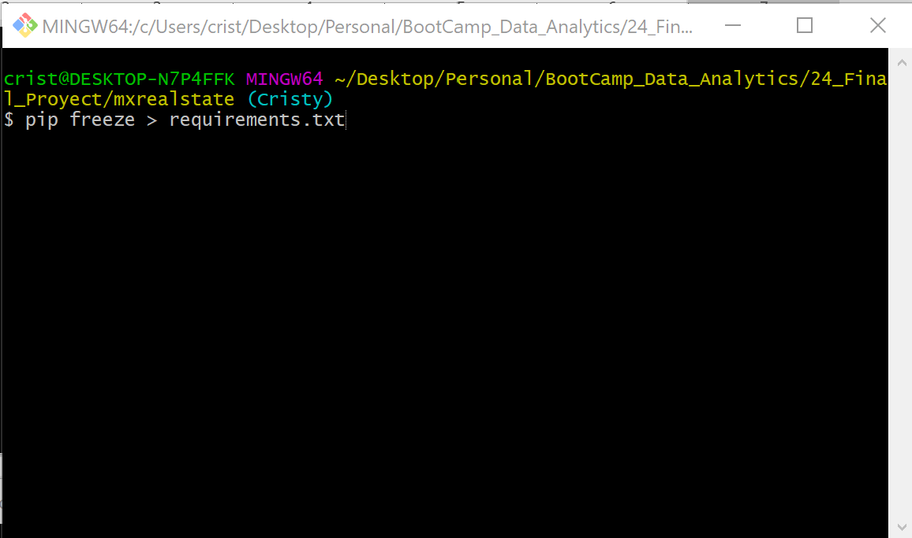

1. Log in into your Heroku account

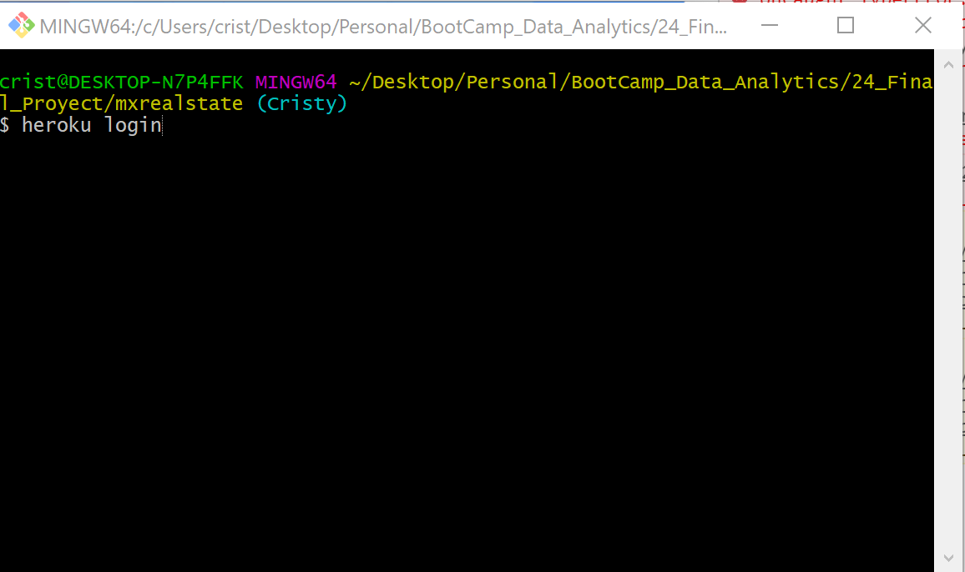

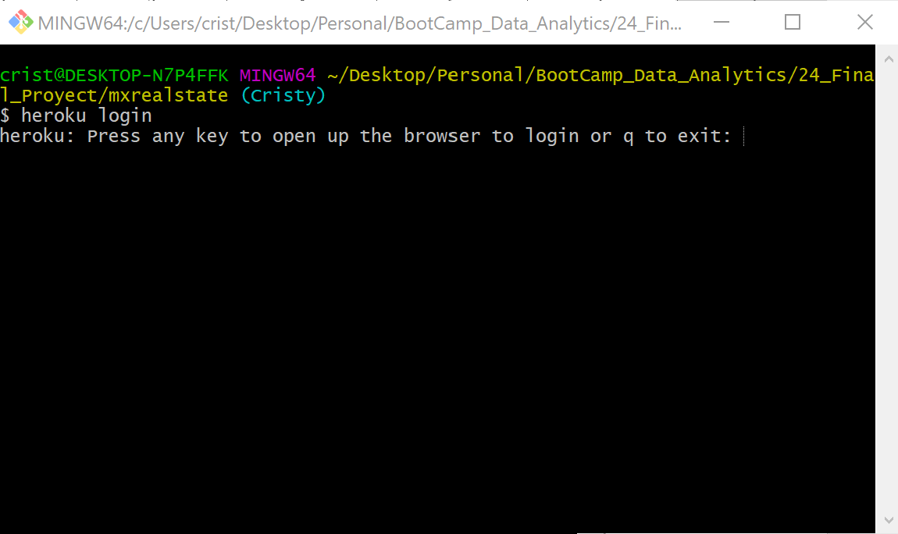

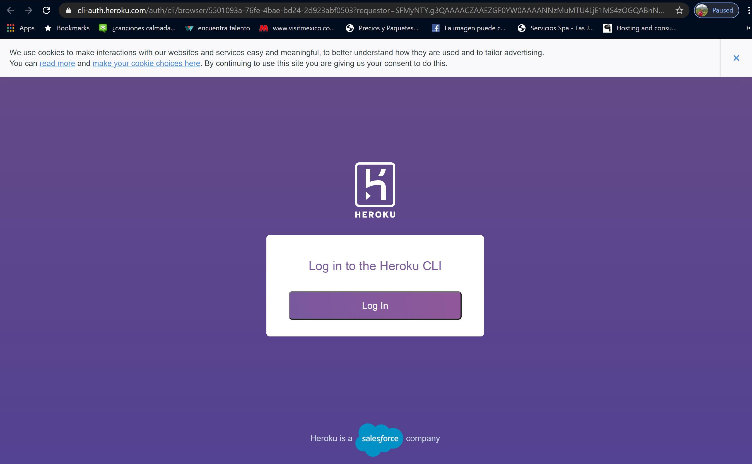



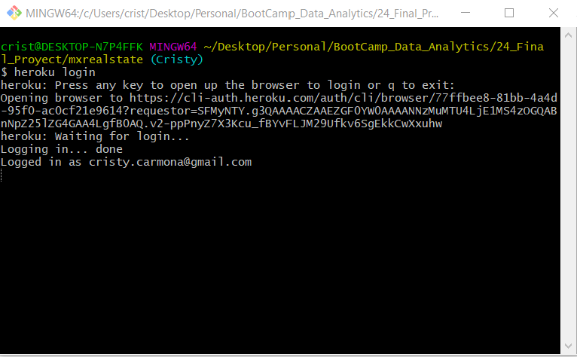

1. Create the site in Heroku:

heroku create **mxrealstate** --buildpack heroku/python

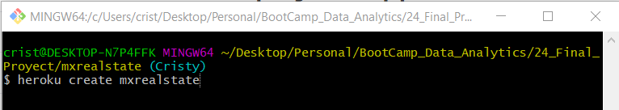

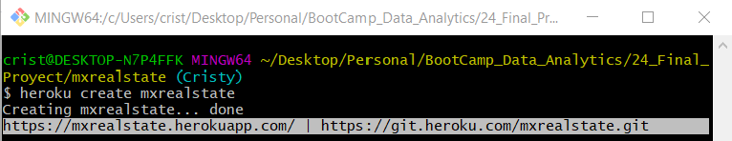

https://mxrealstate.herokuapp.com/ | <https://git.heroku.com/mxrealstate.git>

Note:

* if you want to rename the site name type the following:

heroku rename NewSiteName

* if you create the application without the build pack then execute the following:

heroku buildpacks:set heroku/python

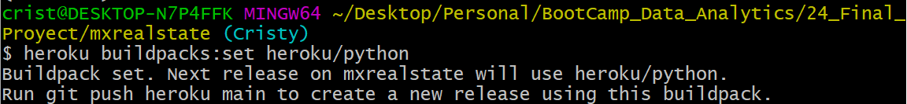

1. Navigate to the given URL:

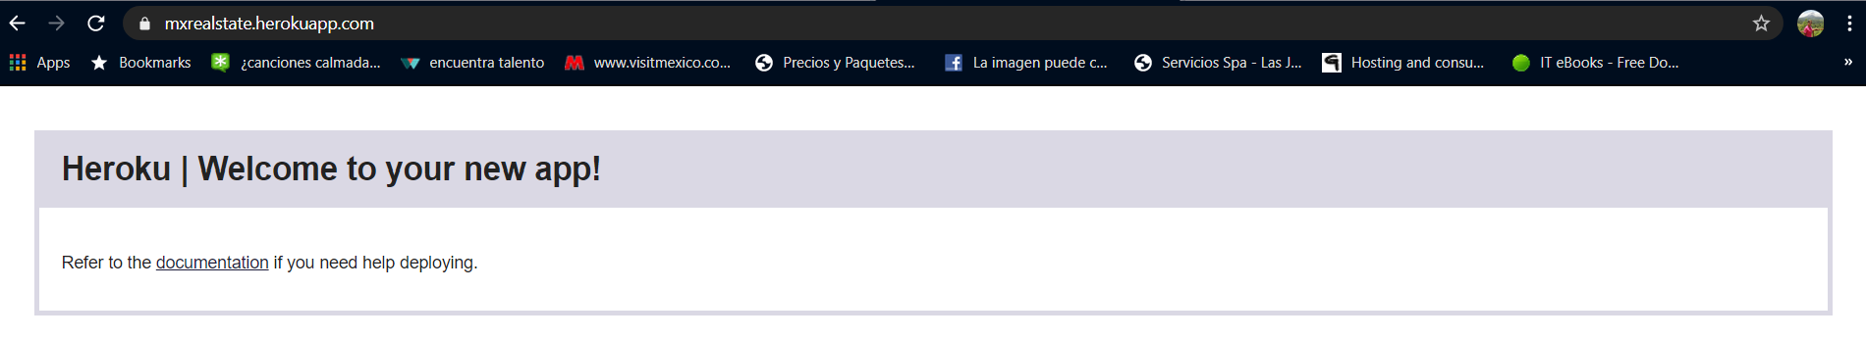

1. Push the code to Heroku:

git push heroku Cristy:master

Note:

Cristy: is the branch with the changes that I’d like to push to Heroku master.

<https://devcenter.heroku.com/articles/git>

<https://devcenter.heroku.com/articles/python-support#supported-runtimes>

<https://devcenter.heroku.com/articles/getting-started-with-python#deploy-the-app>